How to Install GitHub Copilot into PyCharm

A step-by-step guide to enable GitHub Copilot in PyCharm

# Introduction

GitHub Copilot is an AI-powered code completion tool that helps you write better code faster. It works as a plugin for your code editor and suggests relevant code snippets as you type. GitHub Copilot supports a variety of languages and frameworks, and can even generate tests, comments, and documentation for your code.

In this document, you will learn how to install GitHub Copilot into your PyCharm. You will need a GitHub account and a GitHub Copilot technical preview access to use this feature. If you don't have them yet, you can sign up for them here: https://copilot.github.com/

# Installation Steps

1. Download and install the latest version of the PyCharm IDE. You can find the download link here: https://www.jetbrains.com/pycharm/download/.
2. Open PyCharm and select “Plugins”.
3. Click on the Marketplace tab and search for "GitHub Copilot". You should see the GitHub Copilot plugin in the search results. Click on the “Install” button to install it.  
   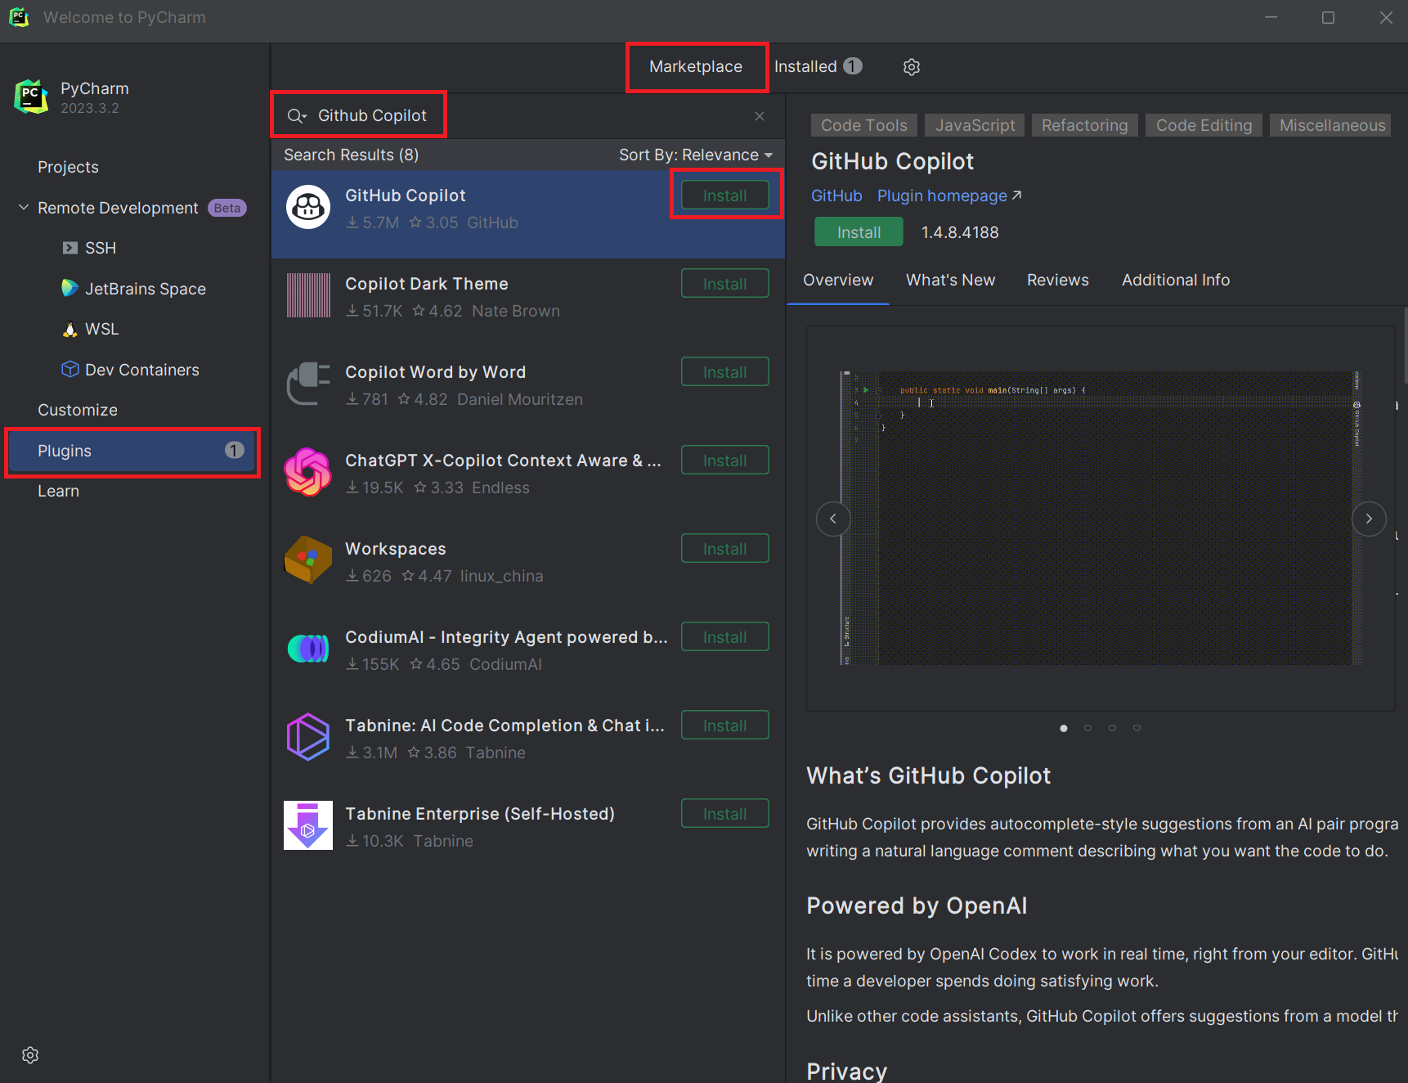
4. Restart PyCharm to activate the plugin.
5. Open a new Python project. You should see a message saying “Welcome to Github Copilot for PyCharm”. Click “Sign in to Github”.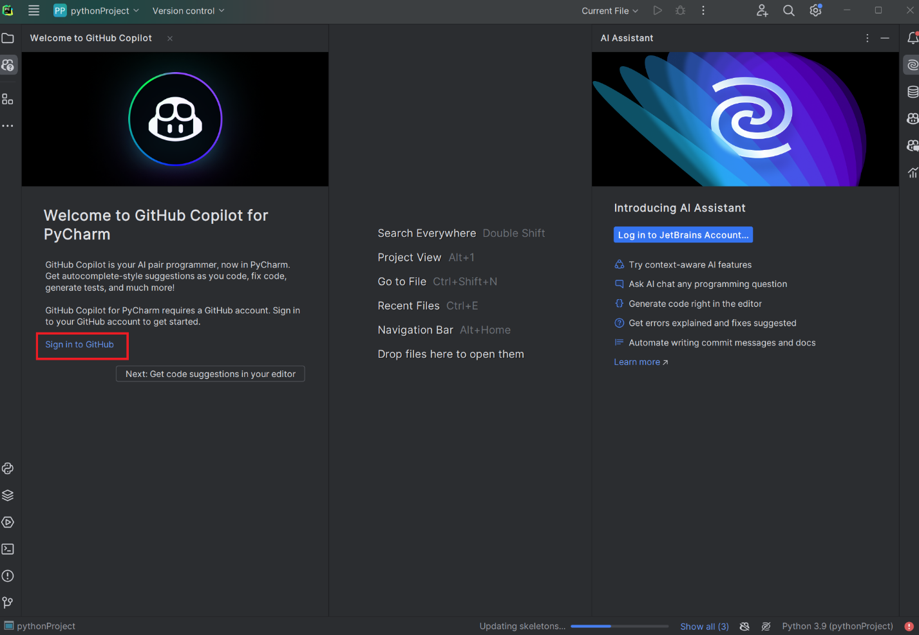
6. You will be given a device code to authorize the plugin to access your Github data. Click “Copy and Open”. You will be directed to Github to log in with your GitHub account and authorize the plugin.  
   A screenshot of a computer

   Description automatically generated
7. Confirm your device is connected  
   A screenshot of a computer

   Description automatically generated
8. Once you are logged in, you can start using GitHub Copilot in your code editor. You will see a Copilot icon in the top right corner of your editor. Click on it to open the Copilot sidebar, where you can see the code suggestions and configure the settings.  
   A screenshot of a computer

   Description automatically generated

# Conclusion

You have successfully installed GitHub Copilot into PyCharm. You can now enjoy the benefits of AI-powered code completion and write better code faster. You can also give feedback to GitHub Copilot by clicking on the thumbs up or thumbs down icons next to the suggestions. For more information and tips on how to use GitHub Copilot, you can visit the official website: https://copilot.github.com/